Test Cases

for

Crowdy
Version 1.1
Prepared by Tan Leong Jun Joseph
SCSJ Group 3, SC2006 Software Engineering, Nanyang Technological University
06/11/2026
Revision History

Name | Date | Reason For Changes | Version
Tan Leong Jun Joseph | 22/10/2026 | Black-box and white-box test cases and results (Lab 4) | 1.0
Tan Leong Jun Joseph | 06/11/2026 | Re-run on the final code and included in the Lab 5 deliverables | 1.1

Introduction

Purpose
This document gives the test case design and testing results for Crowdy. We tested one control class with black-box techniques (equivalence classes and boundary values), and two methods with white-box basis path testing. These test cases were first submitted with the Lab 4 deliverables. For Lab 5 they were run again on the final code on 6 November 2026, and the actual outputs below are from that run. The code under test has not changed since Lab 4, and every case still passes.

How the tests are run
Every test case is automated with Node.js's built-in test runner (node:test). Running npm test in server/ runs 50 server tests, and running it in app/ runs 24 app tests. All 74 pass. Each test case below prints its actual output when it runs, and each section names its test file.

Summary
Technique | Unit under test | Test file | Cases | Result
Black box | AlternativesFinder.findAlternatives | server/tests/alternatives.blackbox.test.ts | 13 | 13 pass
White box | isOpenAt | server/tests/openingHours.basisPath.test.ts | 7 | 7 pass
White box | tokenHits | app/tests/venueSearch.basisPath.test.ts | 6 | 6 pass

Black-Box Testing: AlternativesFinder

Class under test
AlternativesFinder (server/src/services/alternatives.ts) is the control class behind ViewAlternatives (#3-2). Its method findAlternatives(venue, allVenues) returns up to three venues that are the same category, open with a crowd reading, less crowded than the venue being viewed, and within 3 km, closest first.
Test file: server/tests/alternatives.blackbox.test.ts. In every test case the viewed venue is a mall at 60% (Moderate). Each candidate is the same category, Low at 30% and 1 km away, unless the test input says otherwise.

Equivalence classes
Input condition | Valid classes | Invalid classes
Candidate's category | E1: same as the viewed venue | E2: different (for example a station for a mall)
Candidate's crowd status | E3: open with a reading (Low to Very High) | E4: Closed  E5: no reading (Unavailable)
Candidate's crowd % | E6: lower than the viewed venue's | E7: equal to it or higher
Distance from the viewed venue | E8: up to 3 km | E9: more than 3 km
Number of qualifying candidates | E10: 1 to 3 (all returned)  E11: more than 3 (closest 3 returned) | E12: none (nothing shown)

Boundary values
Boundary | Values tested | Expected
Viewed venue's crowd of 60% | Candidate at 59%, 60% and 61% | Only 59% is returned
Distance limit of 3 km | Candidate at 2.999, 3.000 and 3.001 km | 2.999 km and 3.000 km are returned
Result limit of 3 | 3 and 4 qualifying candidates | 3 returned in both cases, closest first

To keep the number of test cases small, one case covers all valid classes together (BB-01), one case covers each invalid class (BB-02 to BB-05), and the boundary cases (BB-06 to BB-13) also cover classes E6 to E9, E10 and E11.

Test cases and results
Outputs are the ids of the returned venues, closest first. [ ] means no alternatives are shown.
ID | Test input | Expected output | Actual output
BB-01 | Same category, Low 30%, 1 km (E1, E3, E6, E8, E10) | [c] | [c]
BB-02 | Candidate is a station (E2) | [ ] | [ ]
BB-03 | Candidate is closed (E4) | [ ] | [ ]
BB-04 | Candidate has no reading (E5) | [ ] | [ ]
BB-05 | No other venues (E12) | [ ] | [ ]
BB-06 | Candidate at 59% | [c] | [c]
BB-07 | Candidate at 60% | [ ] | [ ]
BB-08 | Candidate at 61% | [ ] | [ ]
BB-09 | Candidate 2.999 km away | [c] | [c]
BB-10 | Candidate 3.000 km away | [c] | [c] (first run in Lab 4: [ ], a defect, see below)
BB-11 | Candidate 3.001 km away | [ ] | [ ]
BB-12 | 3 valid candidates at 2, 0.5 and 1 km | [c0.5, c1, c2] | [c0.5, c1, c2]
BB-13 | 4 valid candidates at 2, 0.5, 1 and 1.5 km | [c0.5, c1, c1.5] | [c0.5, c1, c1.5]

Defect found
BB-10 failed on its first run in Lab 4. Floating-point rounding put a venue exactly 3 km away at 3.000000000000002 km, so it was left out, although the requirement says "within 3 km". We changed findAlternatives to round each distance to the nearest metre before comparing it, and all 13 cases now pass.

White-Box Testing: isOpenAt

Method under test
isOpenAt(hours, at) in server/src/services/openingHours.ts decides whether a venue is open at a given moment from its listed opening hours, including hours that run past midnight and venues open round the clock. It returns true, false, or null when the hours can't be read. PopularTimesService uses it so that a mall shows as Closed outside its opening hours (AggregateCrowdData (#1-1)), and the meetup planner uses it for a chosen meeting time.

Control flow graph
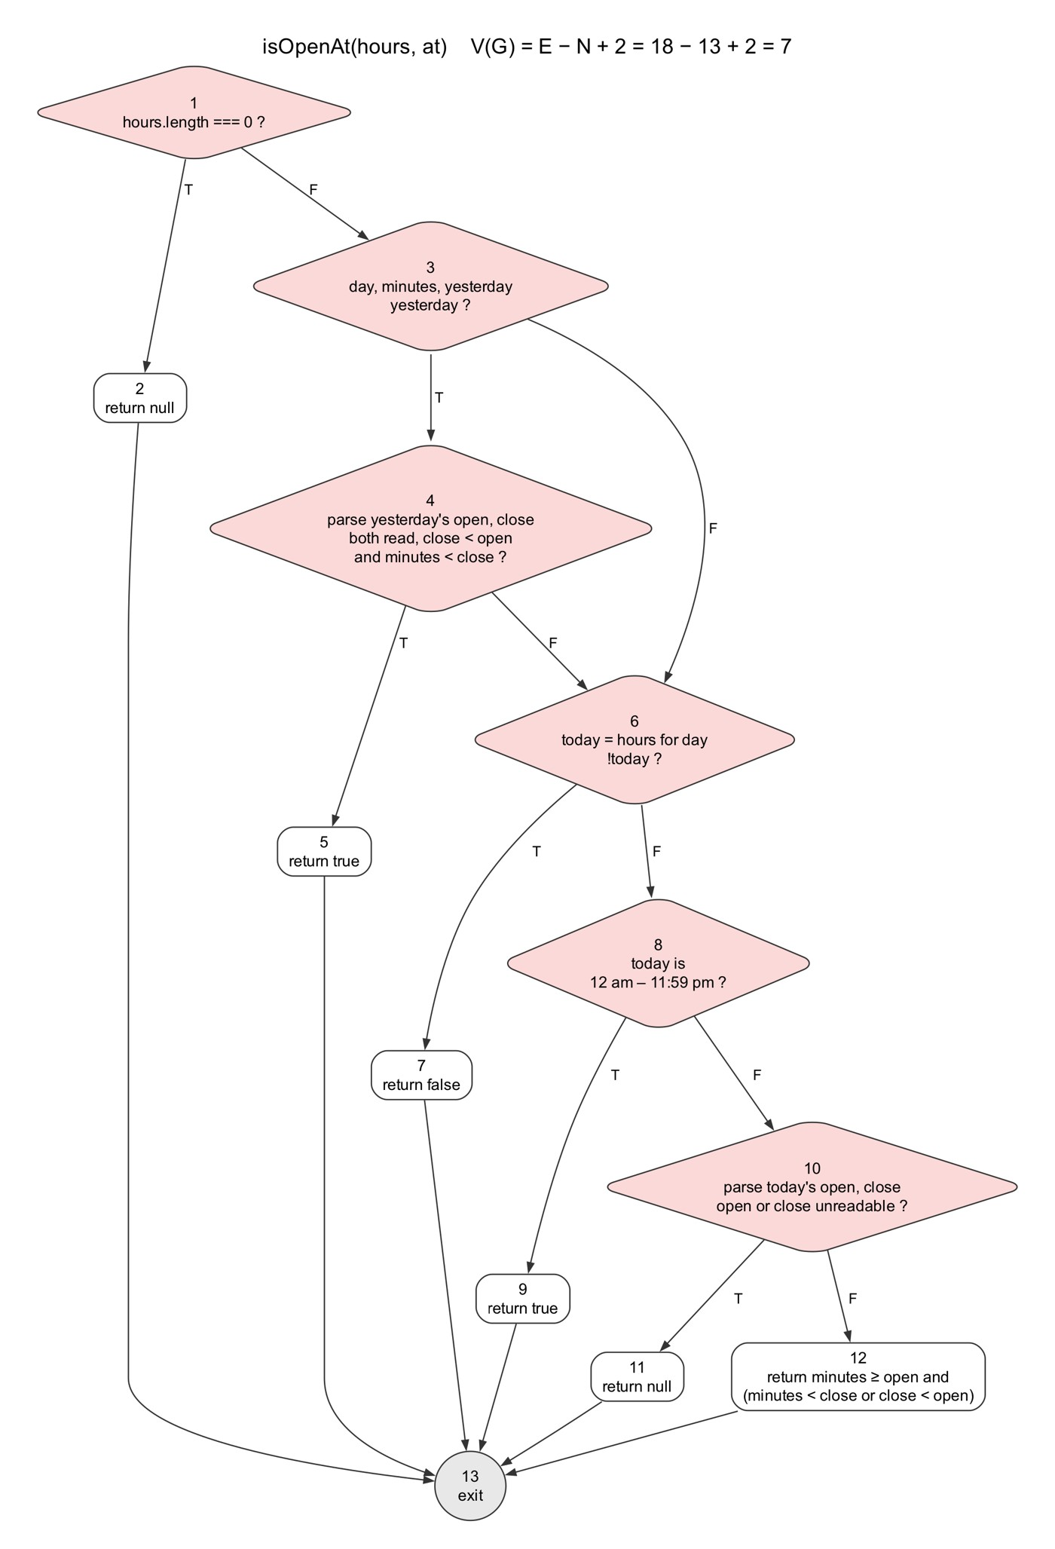
Figure 1. Control flow graph of isOpenAt
Each node is numbered. Diamonds are decisions, with true (T) and false (F) branches. Each compound condition, such as whether yesterday's hours run past midnight, is one decision node.

Cyclomatic complexity
V(G) = E − N + 2 = 18 − 13 + 2 = 7. As a check, the number of decision nodes + 1 = 6 + 1 = 7 (nodes 1, 3, 4, 6, 8 and 10). The basis set therefore has 7 independent paths.

Basis paths
Path | Nodes | What it exercises
WB1-P1 | 1-2-13 | No opening hours listed
WB1-P2 | 1-3-6-7-13 | No hours for yesterday or today
WB1-P3 | 1-3-4-5-13 | Still open on yesterday's hours, which run past midnight
WB1-P4 | 1-3-4-6-7-13 | Yesterday's hours don't reach today, and no hours today
WB1-P5 | 1-3-4-6-8-9-13 | Open round the clock today
WB1-P6 | 1-3-4-6-8-10-11-13 | Today's hours can't be read
WB1-P7 | 1-3-4-6-8-10-12-13 | Normal hours today

Test cases and results
Test file: server/tests/openingHours.basisPath.test.ts. Every test is on Sunday 18 October 2026, so "yesterday" is Saturday.
Path | Test input | Expected output | Actual output
WB1-P1 | hours: none. at: Sunday 3 pm | null | null
WB1-P2 | hours: Wednesday 10 am to 10 pm only. at: Sunday 3 pm | false | false
WB1-P3 | hours: every day 6 pm to 2 am. at: Sunday 1 am | true | true
WB1-P4 | hours: Saturday 10 am to 10 pm only. at: Sunday 3 pm | false | false
WB1-P5 | hours: every day 12 am to 11:59 pm. at: Sunday 3 am | true | true
WB1-P6 | hours: every day "Open 24 hours" (unreadable). at: Sunday 3 pm | null | null
WB1-P7 | hours: every day 10 am to 10 pm. at: Sunday 3 pm | true | true

All 7 basis paths pass, and together they run every edge of the graph.

White-Box Testing: tokenHits

Method under test
tokenHits(queryToken, haystackTokens) in app/src/services/venueSearch.ts is part of SearchController in our design (SearchVenue (#5-1)). For one word the user typed, it looks through a venue's name or address words for the same word, a word starting with it, or a word one typo away (for words of four or more letters). It returns "exact", "prefix", "fuzzy" or null. Exact and prefix matches return straight away. A fuzzy match is only returned if no word starts with the query.

Control flow graph
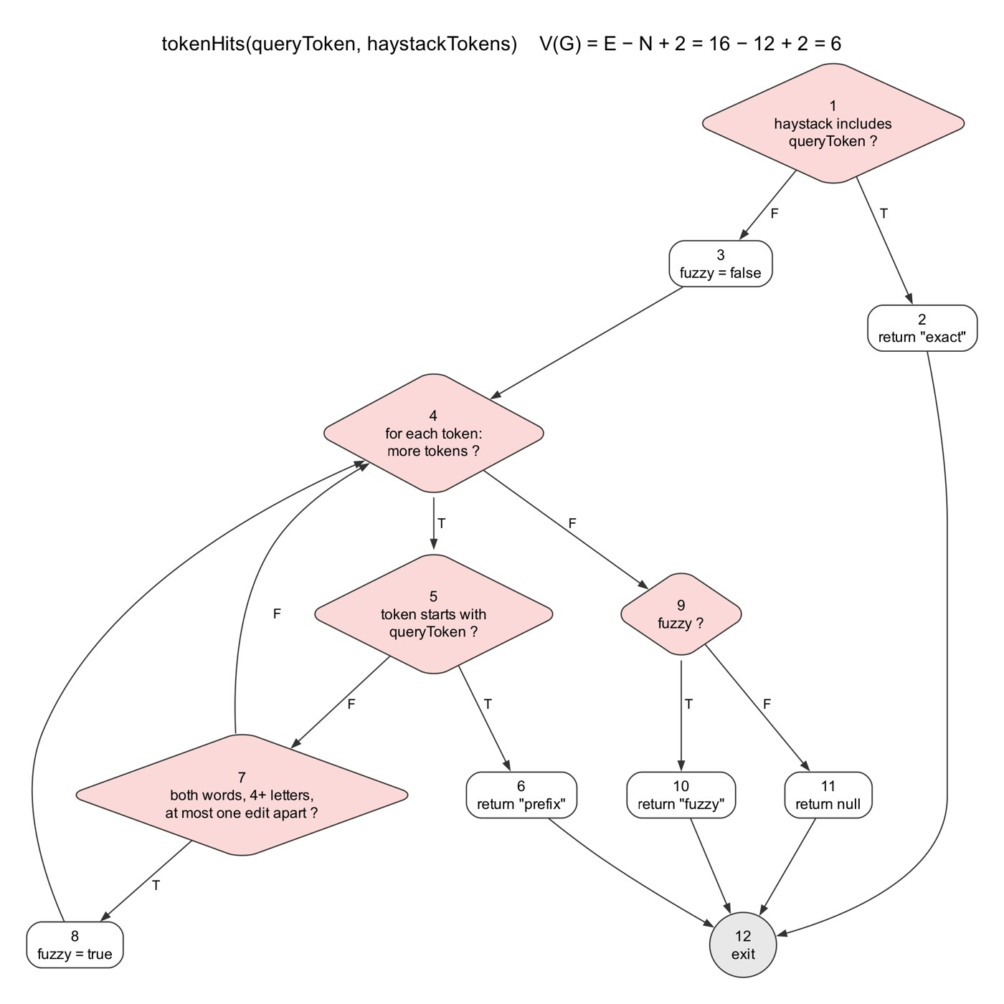
Figure 2. Control flow graph of tokenHits
Node 4 is the loop over the venue's words. The false (F) branch of node 7 goes back to it for the next word.

Cyclomatic complexity
V(G) = E − N + 2 = 16 − 12 + 2 = 6. As a check, the number of decision nodes + 1 = 5 + 1 = 6 (nodes 1, 4, 5, 7 and 9). The basis set therefore has 6 independent paths.

Basis paths
Path | Nodes | What it exercises
WB2-P1 | 1-2-12 | The query is one of the words
WB2-P2 | 1-3-4-9-11-12 | No words to match (the loop runs zero times)
WB2-P3 | 1-3-4-5-6-12 | A word starts with the query
WB2-P4 | 1-3-4-5-7-4-9-11-12 | A word that doesn't match at all
WB2-P5 | 1-3-4-5-7-8-4-9-10-12 | A word one typo away
WB2-P6 | 1-3-4-5-7-8-4-5-6-12 | A word one typo away, then a word starting with the query (prefix wins)

Test cases and results
Test file: app/tests/venueSearch.basisPath.test.ts.
Path | Test input | Expected output | Actual output
WB2-P1 | query: "orchard". words: orchard, road | "exact" | "exact"
WB2-P2 | query: "orchard". words: none | null | null
WB2-P3 | query: "orch". words: orchard | "prefix" | "prefix"
WB2-P4 | query: "bugis". words: orchard | null | null
WB2-P5 | query: "orchrd". words: orchard | "fuzzy" | "fuzzy"
WB2-P6 | query: "vivo". words: viva, vivocity | "prefix" | "prefix"

All 6 basis paths pass, and together they run every edge of the graph.

Other Automated Tests
Besides the designed test cases above, the rest of the suites check the other control classes and routes. They run with the same npm test command and all pass.
Test file | Tests | What it checks
server/tests/alternatives.test.ts | 2 | Alternatives are the same category, less crowded and within 3 km, and only the three closest are kept
server/tests/auth.test.ts | 2 | Sign-up rejects short usernames and passwords, and login gives one message for a missing account or a wrong password
server/tests/favourites.test.ts | 2 | Favourites routes need a token, and saves are written to the account in the token
server/tests/friends.test.ts | 5 | Friend requests, accepting a request by sending one back, home stations shared only with friends
server/tests/meetup.test.ts | 11 | Meetup ranking for each priority, the shortlist, chosen meeting times and closed malls
server/tests/openingHours.test.ts | 7 | Closing times, half-hour times, past-midnight hours, holiday hours labels and incomplete hours lists
server/tests/rateLimit.test.ts | 1 | A client over the limit gets HTTP 429 until the window resets
app/tests/meetingTime.test.ts | 4 | The meeting time picker offers only times within the next week
app/tests/mergeGuestSaves.test.ts | 2 | Guest saves are cleared only after they are merged into an account
app/tests/routeInstructions.test.ts | 5 | Route instructions are translated into Chinese, keeping street names
app/tests/venueSearch.test.ts | 7 | Search ranking, postal codes, road abbreviations and word-start matching

